

**Laxmi Priya**

**Sahoo**

**Luckypriya876@gmail.com**

**7989510530**

**New Delhi, India.**

# Career Objectives

Adaptable and efficiency-oriented Guest Relation Executive with over 5 years of combined experience in business and hospitality management in affluential communicator able to guide cohesive team toward shared goals and advancement. Personable and approachable enjoy meeting and talking with different people. Recognizes and Resolves problem quickly and efficiently to foster positive Relationship with guests to promote customer satisfaction and loyalty.

# KEY SKILLS

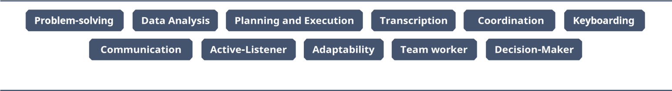

# TECHNICAL DOMAIN SKILL

* Written and excellent verbal communication skill.
* **Operating System:** Windows, Chrome OS.



* **Browsers:** Chrome, Opera, Edge, Safari.

* **Software:** ADB, MS Office, Google Docs.

# EDUCATION

Pursuing MBA in HR from Amity universities College.

Bachelor’s degree in fashion design (BDF) Satwik institution of Professional Studies (SIPS) Bhubaneswar under Utkal _

University of culture, Odisha,

Passed Council of Higher Secondary Education (CHSE) in the year of 2014 in arts stream.



• Awarded With Best Employee of The Year for Outstanding Performance.

# ROLES & RESPONSIBILITIES

* Provide management advice to Helpdesk operators for closing escalated issues.
* Handling Client visits and Events.
* Staff attendance.
* Managing phone call & respond to emails.
* Handling guest request and complaints.
* Scheduling Appointments &Managing Meeting.
* Update file and Records.
* Manage databases.
* Handling pest controlling activities as per Schedule.
* Handling Cafeteria vendors and food Compliance.
* Maintaining office Supplies.
* Booking transport and accommodation.
* Obtaining status report.
* Coordinating with service vendors to close the issues smoothly for operations.
* Coordinating with finance team for invoice processing to on time payments to vendors.
* Knowledge on first AID activity.
* Knowledge on fire & Safety Activities.
* Expertise on Team Management, Vendor Management, Plantation & pantry services.
* Attending Staff monthly training.

**Experience Summary:**

* Currently working as a ACM in Kaya limited New Delhi Location (1st March 2024- Till date)
* Currently Working as a Senior (GRE) Raheja mind space. (1st of April 2022-25th Feb 2024)
* Srushti Baths and Interiors. As a sales executive. (10th February 2020- 31stof March2022)
* Wipro limited as a GRE. (March 2018 to 31st of Jan 2020)

**Accomplishments:**

* + Responsible for driving increased data quality and solving challenges to improve team performance.
  + Being one of the most social and extroverted members of the team was selected for organizing team engagement activities.

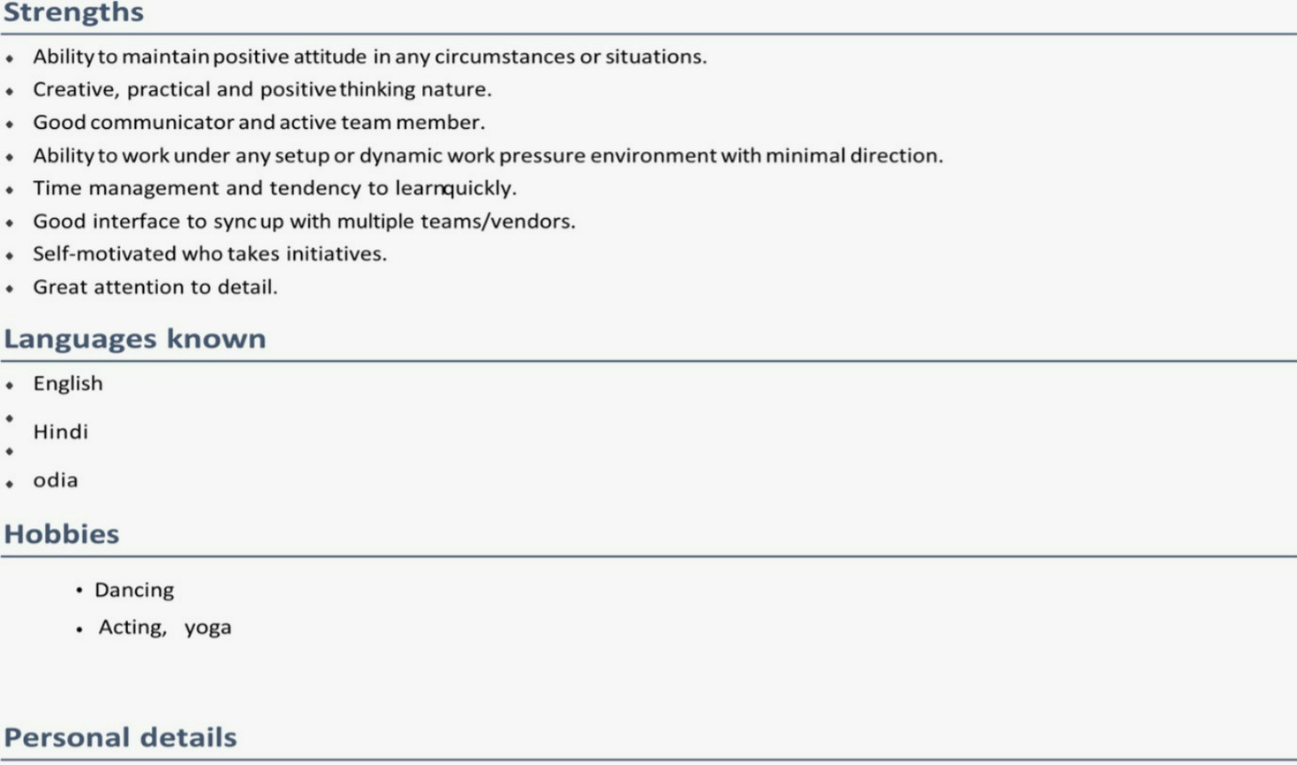

**Name**: - **Laxmi Priya Sahoo**

**Nationality: - Indian**

**Date of birth: - 03-08-1997**

**Marital status: - Single**

**Permanent Adress: - Freedom fighter gali no 4, saket , New delhi.**

**Declaration:**

I hereby declare that all the information mentioned in my resume is true and correct to my knowledge and I take full responsibility for the accuracy of the particulars mentioned.

Place: New Delhi. Laxmi Priya.